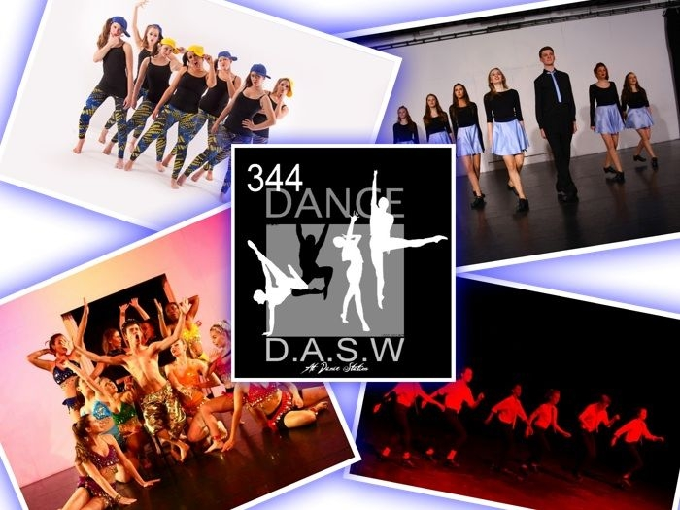

Main Venue: Dance Station, Fishponds

Branches at:-
- The Community Centre, Long Ashton
- The Village Hall, Emersons Green
- Holy Trinity Church, Bradley Stoke
- Basement Studio, 467c Wells Road, Knowle
- The Village Hall, Wickwar

Classes for children from age 2.5 years, students and adults

Ballet ~ Modern Jazz ~ Tap ~ Irish Contemporary ~ DDMix ~ Social Dance
Musical Theatre ~ Singing ~ Drama

Exams ~ ISTD, RAD, LAMDA & LCM

Shows ~ Competitions ~ Summer Schools
Or Just fun!

Principal: Kathy Plaster LISTD Dip, CDE, Cert Ed
344 DANCE SCHOOL was founded in 1984 in the studio at the back of 344 Fishponds Road. In 1995 we moved to our present main venue at Dance Station, Alexandra Park, Fishponds. At Dance Station we have 3 fully equipped studios, a lecture room changing rooms, rest areas and the shop, Kathy’s Dancewear. Our largest studio converts into a studio theatre which seats 104 people and is ideal for our school shows.

Children can just learn for fun or they can take advantage of the many opportunities available to them. We have annual or bi-annual shows, opportunities to compete in our own, local or national competitions and at the end of each term we have examination sessions. These give children the chance to obtain high level qualifications in dancing, acting and singing if they so wish.

Dancing helps them to build confidence, develop good poise and posture, good discipline and develop a social group with similar interests.

Our teachers are all fully qualified and experienced, CRB checked, hold first aid certificates and regularly attend courses to update their knowledge.

Whether you dance at Dance Station or one of our branches, the school has a positive, fun, atmosphere to bring out the love of dance in each of you and help you get the most out of your lessons.

We have had many successes where children from age 11 have gone on to vocational schools such as Elmhurst, Hammond, & the Royal Ballet; students at 16 have achieved scholarships and places at vocational colleges such as Laine, Hammond, Rambert, Northern Ballet School, Northern Contemporary, London Studio Centre, Arts Ed, Italia Conti, Bodyworks, Masters, Bird & Performers; many have had careers performing in the West End, on National Tours and abroad, cruising and others are teaching around Britain and the World.

FOR ADULTS we have one of the largest selection of classes in Bristol. We cater for all levels (beginners to advanced) and for all ages ~ some of our dancers are over 80 years!

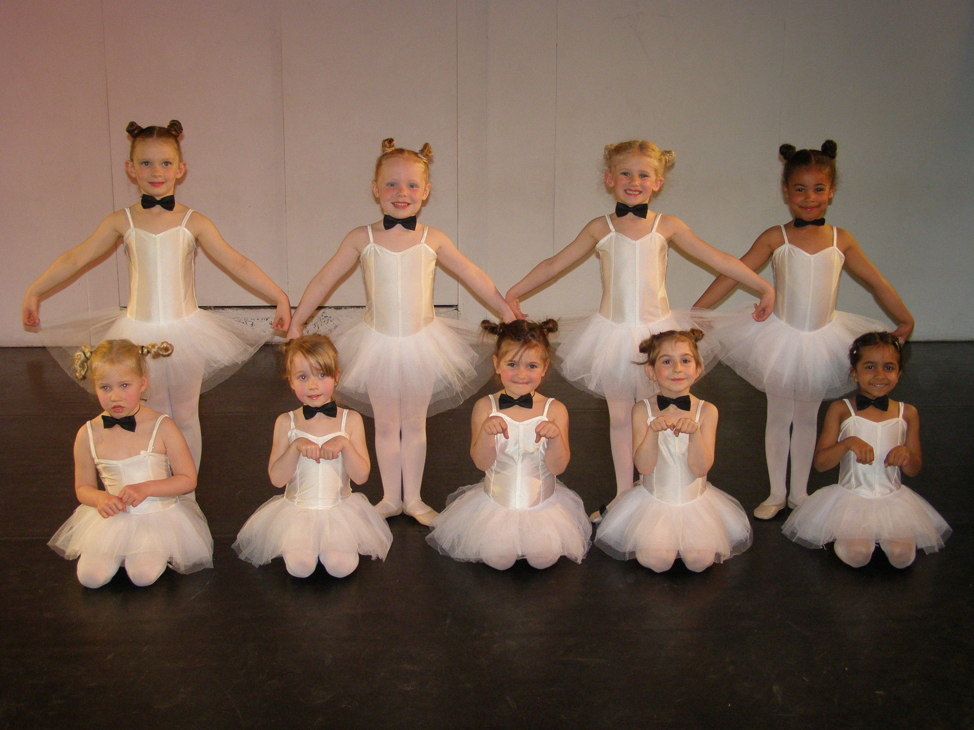

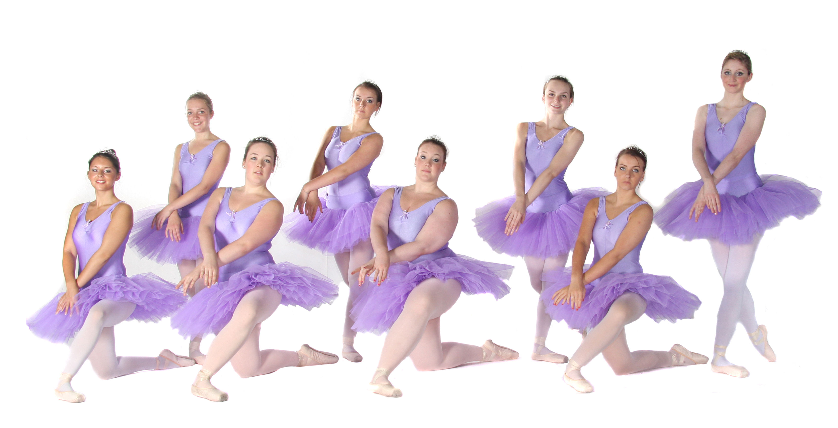

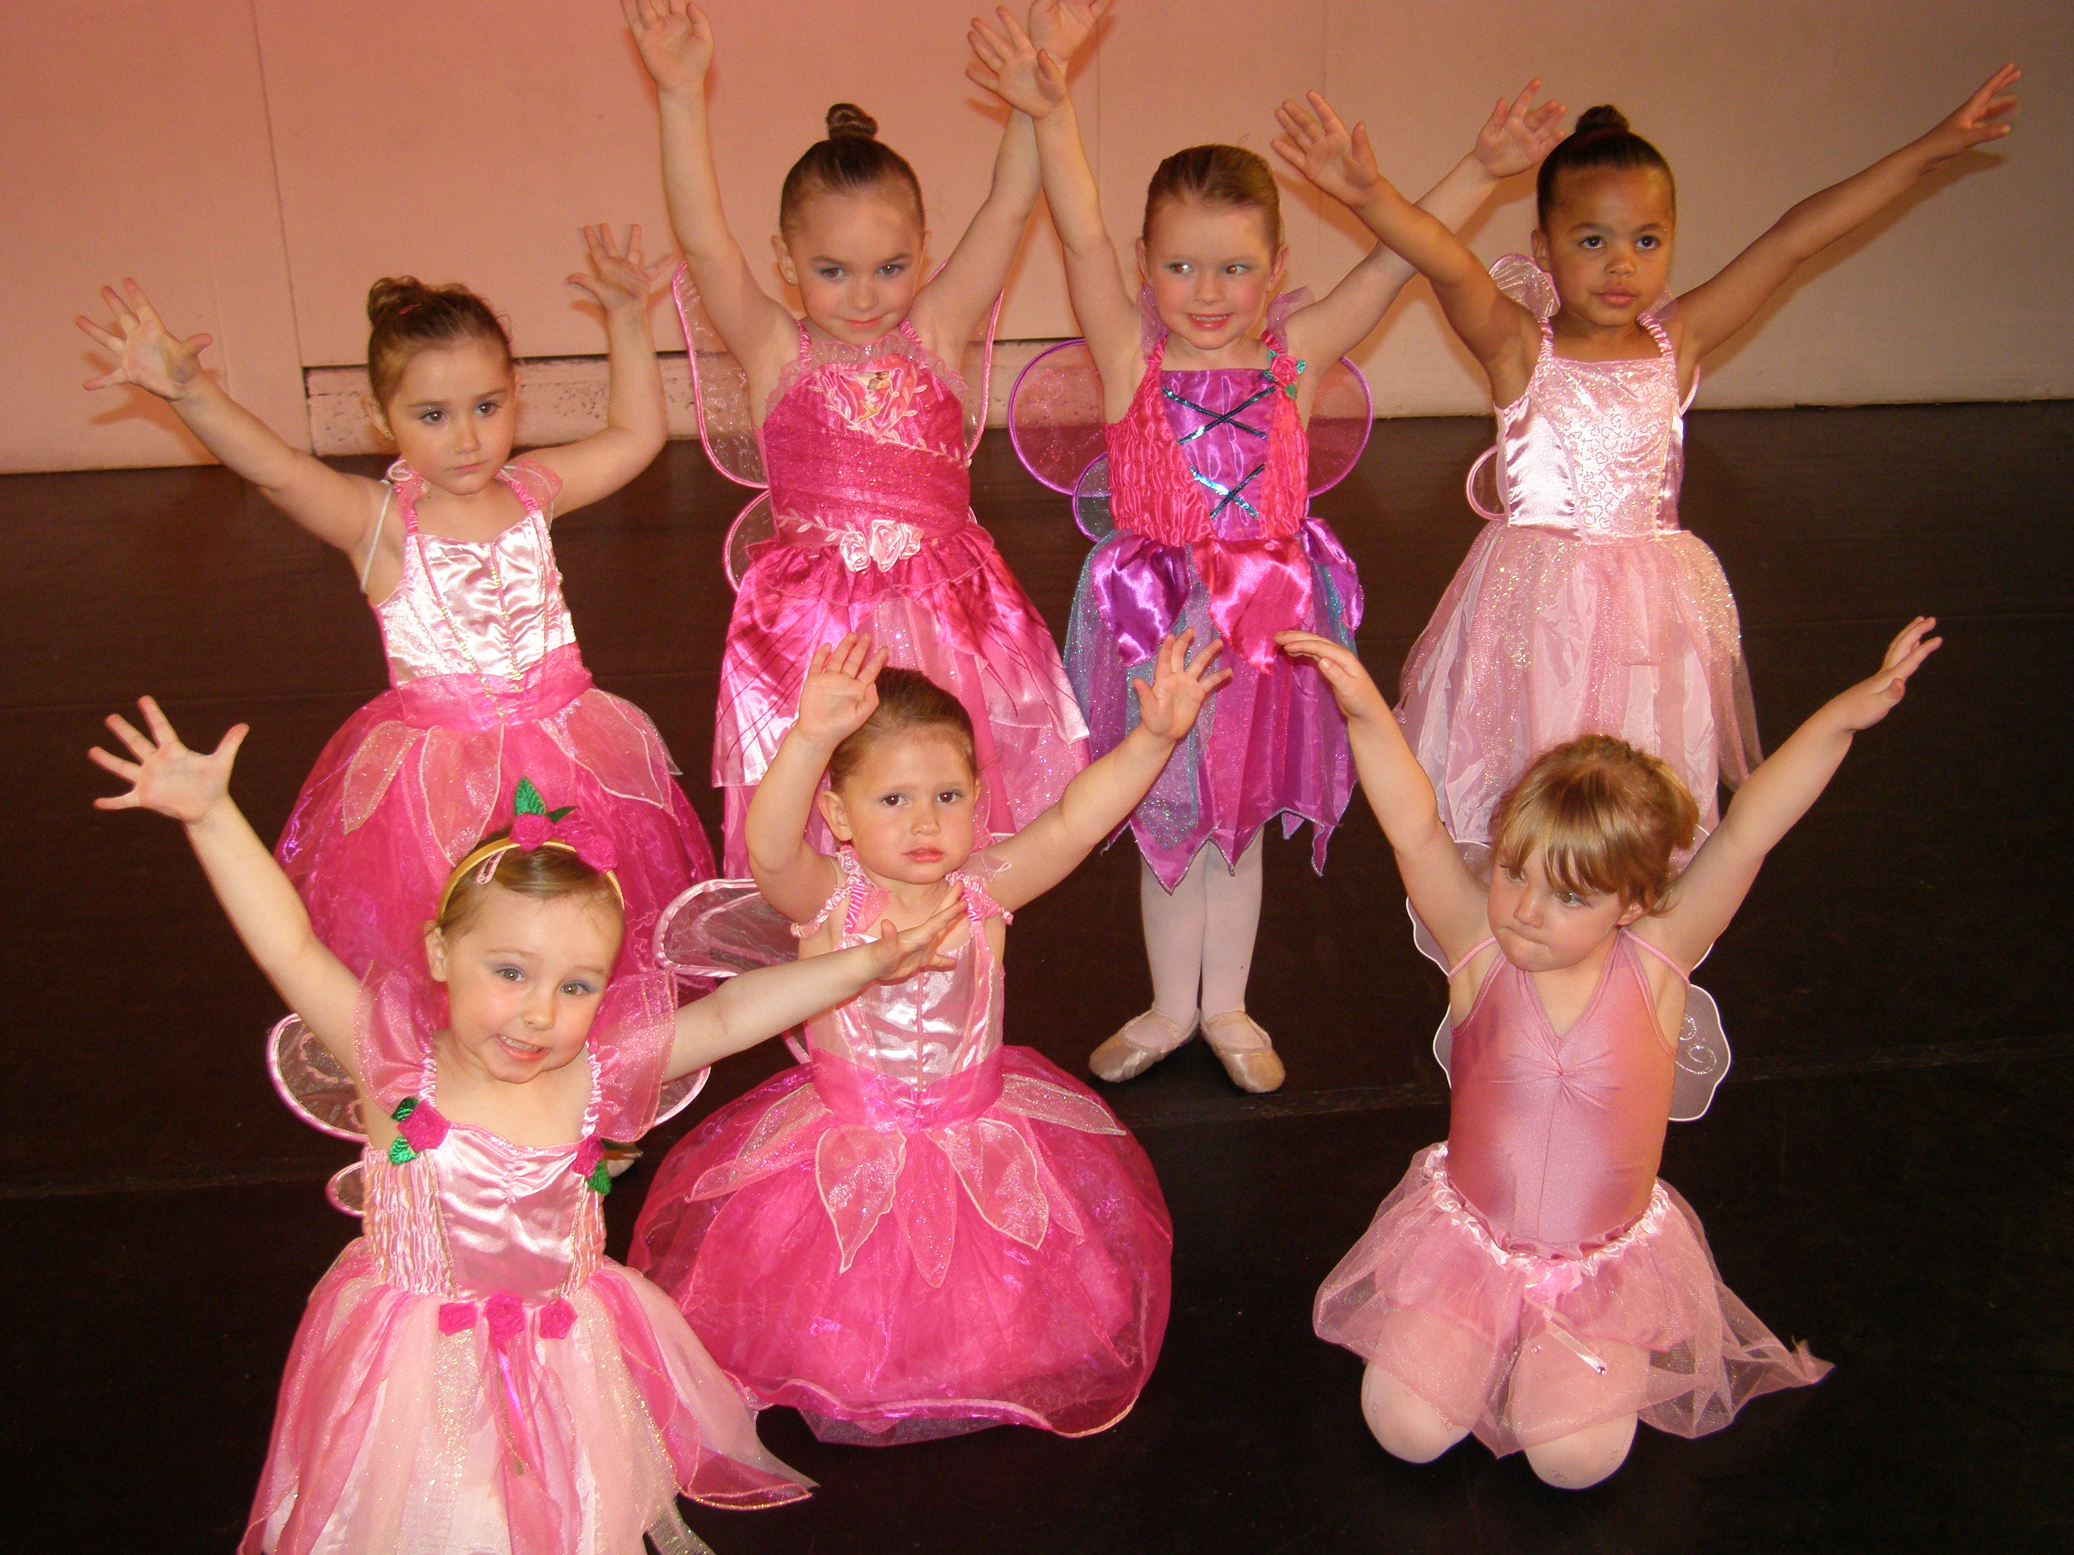

- WE HAVE PRE-SCHOOL CLASSES FROM AGE 2.5 YEARS

- MINIS DANCE & JUNIOR JAZZ AT £50.00 for 10 weeks

- JUNIOR MUSIC THEATRE AT £60 for 10 weeks

- Lower school fees are 30 minute classes are £47.50 for 10 weeks. 45 minute classes are £60 for 10 weeks

- Everyone has a FREE TRIAL LESSON!

- Check out our website regularly
www.344danceschool.com

- Access your term bill and account by using your username and password on our website

- Read your newsletter on the website (if you cannot see this then ask reception or your teacher for a copy)

- Join us on facebook ‘344 Dance School’ – like our page!

- Check out the notice boards at Dance Station or your branch

Your TERM BILL can be viewed 2 weeks before the start of our term and this should be settled at the beginning of term. Any remaining unpaid after 2 weeks of term will be subject to a further £5 administration fee. A term is 10 weeks and we have 3 x 10 week terms and 1 x 8 week term each year. Please note that our terms do not always tie up with school terms although we try to follow the school holidays where possible.

There are discounts applied to the term bills for ballet, modern & tap ~ 10% for 2 subjects, 15% for 3 subjects and 10% if you do more than one lesson of one of these subjects.

Other classes can also be paid for in termly blocks too although they will not attract discounts. One term’s notice is required or, in default, a term’s fees for Childrens classes.

CAR PARKS at Fishponds and Emersons Green are managed and you must put your car registration into the tablet in reception in both venues.



KATHY’S DANCEWEAR is upstairs at Dance Station and supplies all the school uniform. When you join you will receive your 5% loyalty card for the shop and you should show this to receive your discount. All goods should be paid for at time of purchase.

The correct uniform MUST be worn for class. Hair is to be tied back (bun for ballet) and no jewelry should be worn in class. Uniform lists can be obtained from reception or your teacher. Your teacher will advise you when you are ready to commence pointe work and your shoes should be checked with your teacher before they are worn.

EXAMS ~ Your teacher will let you know when you are ready to take an exam and you will receive a letter with full details. It is necessary to have extra exam coaching to prepare so they can be quite costly and fees are needed quite early on.

EISTEDDFODS & COMPETITIONS ~ Your teacher will let you know when you are ready for these. They require a lot of hard work, commitment and support and should only be undertaken by the most dedicated and talented. The dances are taught in private lessons arranged with your teacher. You may be invited to participate in the competition groups too.

SHOWS ~ We hope everyone will participate in these when offered the chance. They are great fun and we endeavour to keep costs to a minimum by often using our own Studio Theatre.

344 DANCE SCHOOL will not tolerate bad or rude behaviour, discrimination of any type or bullying. All pupils will be treated fairly and encouraged to achieve their personal best in every way. Pupils should show respect to each other and their teachers, and be kind, courteous and considerate to all. Teachers will also be required to uphold these expectations. Any student who does not abide by these rules may be requested to leave the school forfeiting any fees already paid.

PLEASE READ OUR PRIVACY POLICY ON OUR WEBSITE

DASW
PART-TIME COURSE FOR TEACHER TRAINING AT DANCE ACADEMY SOUTH WEST AT DANCE STATION

www.danceacademysouthwest.com

Contact details:
344 Dance School
Dance Station
Alexandra Park
Fishponds
Bristol
BS16 2BG
Tel. 0117 9655660
E-mail: admin@dancestation.org.uk
Website: www.344danceschool.com

